NAME:SOORYA S
REG NO:23CS116
SUBJECT :BI

UNIT 4 ACTIVTY 2

Title:
Practical Exploration of Sentiment Analysis on Real-Time Product Reviews or Tweets

Objective:
To practically explore and apply sentiment analysis techniques on real-time data such as product reviews or tweets, and to interpret user opinions for decision-making.

Aim:
To perform sentiment analysis on real-time text data to classify opinions as positive, negative, or neutral, using text mining and natural language processing techniques.

Tools and Technologies:
• Programming Language: Python
• Libraries/Packages: NLTK, TextBlob, VADER, pandas, matplotlib, seaborn
• Optional: Tweepy (for Twitter data), BeautifulSoup (for web scraping)
• Platform: Jupyter Notebook / Google Colab / RapidMiner

Task Description:
1. Collected real-time customer reviews from food delivery platform - Uber Eats using web scraping tools or publicly available review datasets.Data Collection

.2. Data Preprocessing
• Removal of special characters, emojis, and links
• Tokenization and stop-word removal
• Stemming or lemmatization
• Lowercasing of text

3. Sentiment Analysis
- Lexicon-Based Approach: VADER, TextBlob
- Machine Learning Approach (optional): Naïve Bayes, Logistic Regression
- Classified comments into:– Positive– Negative– Neutral
4. Data Visualization
• Bar chart showing sentiment distribution
• Pie chart of sentiment proportions
• Word cloud for frequent positive/negative words

5. Result Interpretation
• Analyzed the sentiment results to understand customer satisfaction with food quality and delivery services
• Identified common complaints such as late delivery, cold food, poor packaging, or app issues
• Summarized the overall sentiment of customers toward the food delivery platform
Expected Outcome:
• A preprocessed dataset of real-time food delivery app reviews with sentiment labels
• Visual representations (bar charts, pie charts, word clouds) showing sentiment trends
• A clear summary describing customer opinions, satisfaction level, and service quality insights

FULL PYTHON CODE FOR SENTIMENT ANALYSIS
import pandas as pd
import numpy as np
import re
import nltk
from nltk.corpus import stopwords
from nltk.stem import WordNetLemmatizer
from nltk.tokenize import word_tokenize
from nltk.sentiment.vader import SentimentIntensityAnalyzer
import matplotlib.pyplot as plt
import seaborn as sns
from wordcloud import WordCloud
import nltk
nltk.download('punkt')
nltk.download('stopwords')
nltk.download('wordnet')
data = {
"text": [
"Fast delivery and great restaurant options.",
"App crashes frequently after the latest update.",
"Food prices are reasonable but delivery fee is too high.",
"Excellent packaging and fresh food.",
"Promo codes rarely work.",
"Delivery partner followed instructions perfectly.",
"Live tracking sometimes freezes.",
"Very convenient for late-night orders.",
"Customer support was unhelpful during my refund request.",
"Smooth and clean UI. Easy to navigate."
]
}df = pd.DataFrame(data)

def clean_text(text):
text = text.lower()
text = re.sub(r"http\S+|www\S+", "", text) # remove links
text = re.sub(r"[^a-zA-Z ]", "", text) # remove emojis/symbols
text = text.strip()
return text
# Define stopwords + lemmatizer
stop_words = set(stopwords.words("english"))
lemmatizer = WordNetLemmatizer()
# Preprocessing function
def preprocess_text(text):
text = clean_text(text)
tokens = word_tokenize(text)
tokens = [
lemmatizer.lemmatize(word)
for word in tokens if word not in stop_words
]return " ".join(tokens)
# Apply preprocessing
df["clean_comment"] = df["comment"].apply(preprocess_text)
sia = SentimentIntensityAnalyzer()
def get_sentiment(text):
score = sia.polarity_scores(text)
compound = score['compound']
if compound >= 0.05:
return "Positive"
elif compound <= -0.05:
return "Negative"
else:
return "Neutral"
df["Sentiment"] = df["clean_comment"].apply(get_sentiment)
plt.figure(figsize=(7,5))
sns.countplot(x=df["Sentiment"], palette="Set2")
plt.title("Sentiment Distribution (YouTube Comments)")
plt.xlabel("Sentiment")
plt.ylabel("Count")
plt.show()
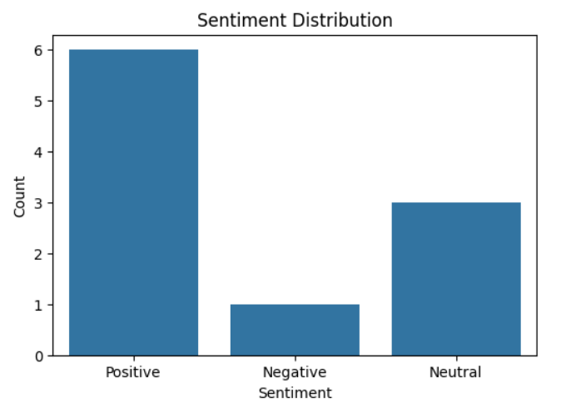
# 7. Visualization – Pie Chart
plt.figure(figsize=(6,6))
df["Sentiment"].value_counts().plot(
kind='pie', autopct='%1.1f%%'
)
plt.title("Sentiment Proportion")
plt.ylabel("")
plt.show()
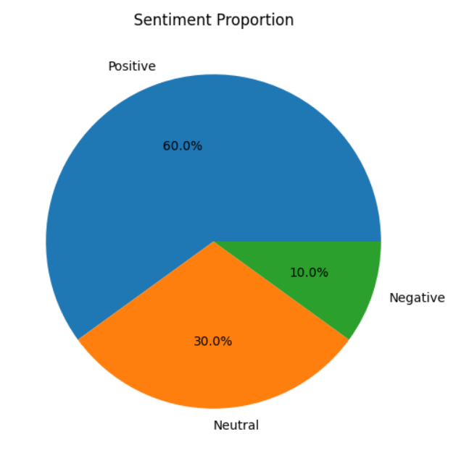

# 8. Word Cloud – Positive
positive_text = " ".join(df[df["Sentiment"] == "Positive"]["clean_comment"])
if positive_text.strip():
wc = WordCloud(width=800, height=400).generate(positive_text)
plt.imshow(wc)
plt.axis("off")
plt.title("Positive Word Cloud")
plt.show()
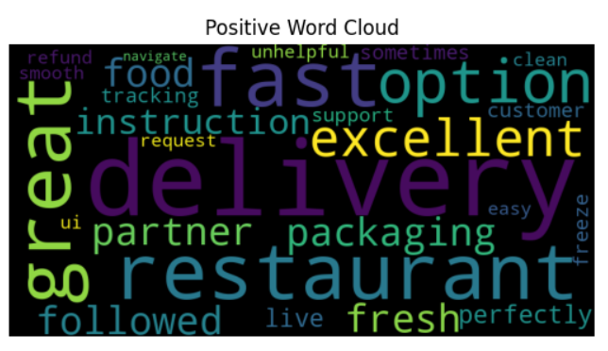
# 9. Word Cloud – Negative
negative_text = " ".join(df[df["Sentiment"] == "Negative"]["clean_comment"])
if negative_text.strip():
wc = WordCloud(width=800, height=400).generate(negative_text)
plt.imshow(wc)
plt.axis("off")
plt.title("Negative Word Cloud")
plt.show()
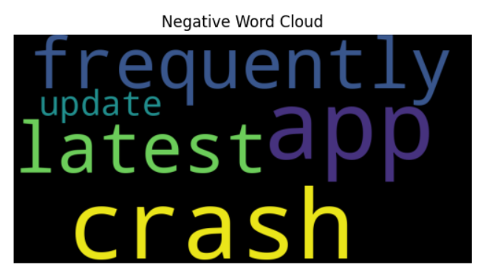
# 10. Word Cloud – Neutral
neutral_text = " ".join(df[df["Sentiment"] == "Neutral"]["clean_comment"])
if neutral_text.strip():
wc = WordCloud(width=800, height=400).generate(neutral_text)
plt.imshow(wc)
plt.axis("off")
plt.title("Neutral Word Cloud")
plt.show()
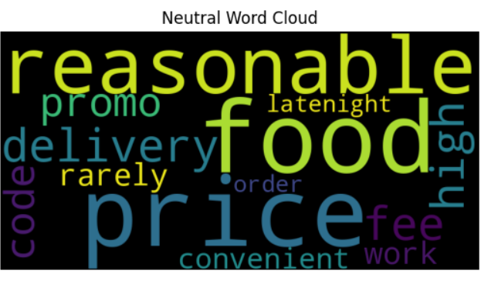
# 10. Summary & Insights
print("=== Sentiment Summary ===")
print(df["Sentiment"].value_counts())
print("\n=== Insights ===")
dominant = df["Sentiment"].value_counts().idxmax()
if dominant == "Positive":
print("Overall sentiment is POSITIVE. Customers are happy with delivery service and app usability.")
elif dominant == "Negative":
print("Overall sentiment is NEGATIVE. Users reported issues like app crashes, high delivery fees, and poor support.")
else:
print("Overall sentiment is NEUTRAL. Mixed experiences with food delivery services.")
=== Sentiment Summary ===
Sentiment
Positive 6
Neutral 3
Negative 1
Name: count, dtype: int64
=== Insights ===
Overall sentiment is POSITIVE. Customers are happy with delivery service and app usability.

